High-Risk Newborn:

Clubfoot

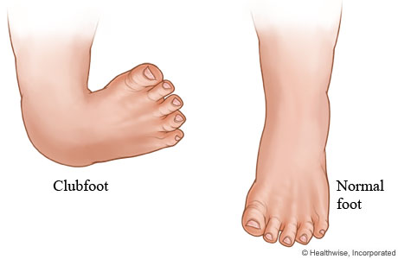What is clubfoot?
Clubfoot, also known as talipes equinovarus, is a congenital (present at birth) foot deformity. It affects the bones, muscles, tendons, and blood vessels and can affect one or both feet. The foot is usually short and broad in appearance and the heel points downward while the front half of the foot (forefoot) turns inward. The heel cord (Achilles tendon) is tight. The heel can appear narrow and the muscles in the calf are smaller compared to a normal lower leg.
It occurs in about one in every 1,000 live births and affects boys twice as often as girls. About half of clubfoot cases affect both feet.

What causes clubfoot?
Clubfoot is considered a "multifactorial trait." Multifactorial inheritance means there are many factors involved in causing a birth defect. The factors are usually both genetic and environmental.
Often one gender (either male or female) is affected more frequently than the other in multifactorial traits. There appears to be a different "threshold of expression," which means that one gender is more likely to show the problem than the other gender. For example, clubfoot is twice as common in males as it is in females. Once a baby has been born with clubfoot, the chance for it to happen again in a male or female child is about 4 percent overall. In other words, there is a 96 percent chance that another baby would not be born with clubfoot.

What are the risk factors for clubfoot?
Risk factors may include the following:
- family history of clubfoot
- position of the baby in the uterus
- increased occurrences in those babies with neuromuscular disorders, such as cerebral palsy (CP) and spina bifida
- oligohydramnios (decreased amount of amniotic fluid surrounding the fetus in the uterus) during pregnancy
Babies born with clubfoot may also be at increased risk of having an associated hip condition, known as developmental dysplasia of the hip (DDH). DDH is a condition of the hip joint in which the top of the thigh bone (femur) slips in and out of its socket because the socket is too shallow to keep the joint intact.

How is clubfoot diagnosed?
Your baby's physician makes the diagnosis of clubfoot at birth with a physical examination. During the examination, your baby's physician obtains a complete prenatal and birth history of the baby and asks if other family members are known to have clubfoot. If the diagnosis of clubfoot is made in an older infant or child, the physician will also ask about developmental milestones since clubfoot can be associated with other neuromuscular disorders. Developmental delays may require further medical follow up to evaluate for underlying problems.
Diagnostic procedures of the foot may include:
- x-ray - a diagnostic test which uses invisible electromagnetic energy beams to produce images of internal tissues, bones, and organs onto film.
- computed tomography scan (Also called a CT or CAT scan.) - a diagnostic imaging procedure that uses a combination of x-rays and computer technology to produce cross-sectional images (often called slices), both horizontally and vertically, of the body. A CT scan shows detailed images of any part of the body, including the bones, muscles, fat, and organs. CT scans are more detailed than general x-rays.
The affected foot may be flexible, known as a "positional clubfoot." This flexible type of clubfoot is caused by the baby's position in the uterus. Positional clubfoot can easily be positioned into a neutral (not curved) position by hand. A true clubfoot is stiff, or rigid, and very hard to manipulate.
The symptoms of clubfoot may resemble other medical conditions of the foot. Always consult your baby's physician for a diagnosis.

Treatment for clubfoot:
Specific treatment for clubfoot will be determined by your baby's physician based on:
- your baby 's gestational age, overall health, and medical history
- the extent of the condition
- your baby's tolerance for specific medications, procedures, or therapies
- expectations for the course of the condition
- your opinion or preference
The goal of treatment is to straighten the foot so that it can grow and develop normally. Treatment options for babies include:

- Nonsurgical treatment:
There are various methods of nonsurgical treatment for infants with clubfoot. These methods include serial manipulation and casting, taping, physical therapy and splinting, and use of a machine that provides continuous passive motion. A nonsurgical treatment should be the first type of treatment for clubfoot, regardless of how severe the deformity is. Most cases of clubfoot can be treated nonsurgically.
Serial manipulation and Casting (Ponseti Method):
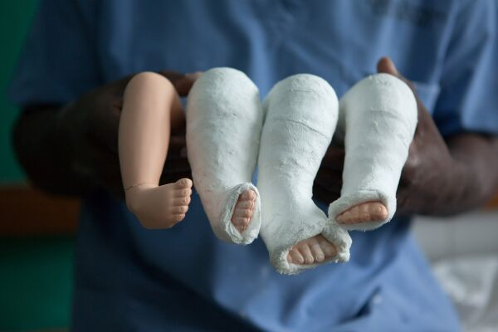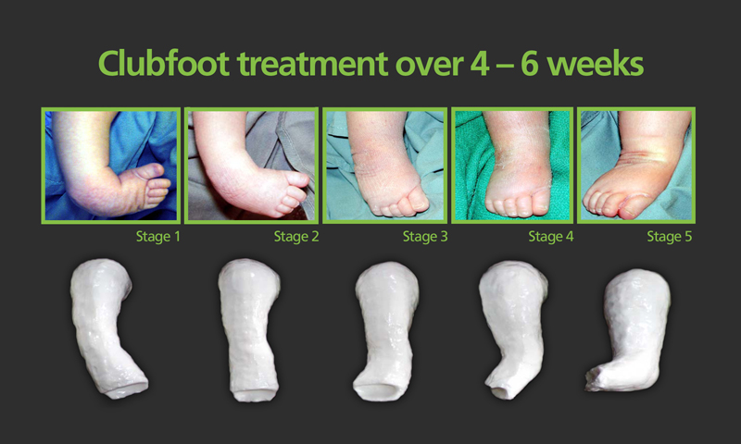In this method, the child’s foot is ‘manipulated’ into the right position. This means that the doctor will gently stretch the foot by hand. The foot is then covered in plaster cast to keep it in the right position. It can take a series of casts over a few months before the club foot is corrected.

These pictures show how manipulation and casting works. Over a period of 2-3 months, the foot is corrected to a normal position

According to the American Academy of Orthopaedic Surgeons (AAOS), the Ponseti method, which uses manipulation and casting, is the most frequently used method in the US to treat clubfoot. Most cases of clubfoot in infants can be corrected within 2 to 3 months using this method. It is recommended that Ponseti method treatment be started as soon as clubfoot has been diagnosed, even as soon as one week of age. The AAOS states that fewer than 5 percent of infants with clubfoot have a deformity severe enough that manipulation and casting will not be effective.
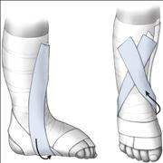Stretching and Taping (French Method)
In this method the foot is gently stretched by hand then taped in place by a physiotherapist. This is done daily, instead of weekly or monthly for the Ponseti Method.
Splinting
Because clubfoot may recur, braces are worn for several years to prevent relapse. Initially, the braces are worn for 23 hours a day for up to 3 months, then at night for 2 to 4 years.
- Surgery
Surgical treatment for clubfoot may be required in these situations:
  - when nonsurgical treatment fails to correct the deformity, or
  - when the deformity recurs and does not respond to nonsurgical treatment.
The specific surgical procedure and extent of surgery will depend on the type and extent of the deformity. Postoperatively, surgical wires, pins, and/or a cast may be used to maintain the corrected foot position until it has healed. Splints may also be needed for several months up to a few years after surgery.

What are long leg casts?
Long leg casts are applied from the upper thigh to the foot. These casts are used for thigh, knee, or lower leg fractures. They can also be used with knee dislocations or after surgery on the leg or knee area.

What are short leg casts?
A short leg cast is applied to the area below the knee to the foot. This type of leg cast is used for leg fractures and severe ankle sprains/strains or fractures. A short leg cast may also be used to hold the leg or foot muscles and tendon in place after surgery to allow healing.

Cast care instructions:
- Keep the cast clean and dry.
- Check for cracks or breaks in the cast.
- Rough edges can be padded to protect the skin from scratches.
- Do not scratch the skin under the cast by inserting objects inside the cast.
- Use a hairdryer placed on a cool setting to blow air under the cast and cool down the hot, itchy skin. Never blow warm or hot air into the cast.
- Do not put powders or lotion inside the cast.
- Cover the cast during feedings to prevent spills from entering the cast.
- Prevent small toys or objects from being put inside the cast.
- Elevate the cast above the level of the heart to decrease swelling.

When to call your baby's doctor:
Contact your physician if your baby develops one or more of the following symptoms:
- fever
- increased pain
- increased swelling above or below the cast
- drainage or foul odor from the cast
- cool or cold toes

Long-term outlook for a baby with clubfoot:
Most babies with clubfoot can be corrected with serial manipulation and casting. Some babies may require surgery to help correct the position of the foot. Additional surgeries may be necessary since the deformity may come back as the child grows and develops.

